Vlocity Summer Release ‘21

**October 22, 2021**

**Version: 1.0**

Table of Contents

1. Pre - Upgrade Steps: 3

2. Upgrade Steps: 8

3. Post Upgrade Steps: 10

**Important** 12

**Upgrading the Vlocity Communications, Media, and Energy Applications Package to Summer ‘21**

# 1. Pre - Upgrade Steps:

1. Find and note the package versions currently installed in your org so you can reference these versions during the Upgrade Steps:
   1. From Setup, in the **Quick Find** box, enter *Installed Packages*.
   2. Click **Installed Packages**.
   3. On the Installed Packages page, look for the Version Number of the following packages.
      * Vlocity CMT
      * Vlocity Installation CMT/ Vlocity Installation Assistant CMT

The Vlocity Managed Package cannot be uninstalled. Vlocity maintains a fix-forward methodology when resolving packaging issues and bugs.

1. Log off all orgs except the org where you are performing the installation. Make sure you are logged into only one environment and that you do not deploy the managed package to the wrong environment.

Verify the correct environment:

1. Copy the tail of the package URL. If the package link is:

**https://login.salesforce.com/packaging/installPackage.apexp?p0=04t1J000000mW3S**, the tail of the URL would be **/packaging/installPackage.apexp?p0=04t1J000000mW3S**.

1. Copy the tail of the package URL(Sandbox). If the package link is:

**https://test.salesforce.com/packaging/installPackage.apexp?p0=04t1J000000mW3S**, the tail of the URL would be **/packaging/installPackage.apexp?p0=04t1J000000mW3S**.

1. Check the URL tail to check the package along with the package ID, for example, 4t1J000000mW3S.

Alternatively, if you are logged out of all other environments, click the installation URL for the major release package in the release summary table below.

1. Ensure the Salesforce Recycle Bin is empty, and that your strategic backup plan that does not involve using the Recycle Bin.

**Important: (Need to confirm with Business)**

***If the Salesforce Recycle Bin is not empty, the package deployment may fail.***

In Salesforce Lightning, you can use the App Launcher to find the Recycle Bin.

Click **Empty Org Recycle Bin**.

1. Ensure that Deliverability is set to All Email:
   1. From Setup, in the **Quick Find** box, enter *Deliverability*.
   2. Click **Deliverability**.
   3. Click the dropdown for **Access level** and set to **All Email**.
   4. Click **Save**.
2. Ensure Enhanced Email is enabled:
   1. From Setup, in the **Quick Find** box, enter *Enhanced Email*.
   2. Click **Enhanced Email**.
   3. Make sure **Enhanced Email** is enabled. (which is already enabled in our Org)
3. Set up Content Deliveries:
   1. From Setup, in the **Quick Find** box, enter *content deliveries and public links*.
   2. Click **Content Deliveries and Public Links**.
   3. Click **Content Deliveries feature can be enabled for users**.
   4. Click **Public Links can be enabled for users (Requires Content Deliveries)**.
   5. Click **Content Deliveries and Public Links can be enabled to let communities’ users share files managed by libraries (Requires Content Deliveries)**.
   6. Choose a default option for content-delivery passwords:
   * **Password protection is optional and defaults to OFF**—If this option is selected, users can choose to require a password when they create a content delivery, but the Require Password to Access Content field on the create-delivery wizard is not selected by default.
   1. Click **Save**.
4. Enable Orders:
   1. From Setup, in the **Quick Find** box, enter *Order*.
   2. Click **Order Settings** and click **Enable**.
   3. Click **Save**.
5. Enable Work Orders:
   1. From **Setup**, in the **Quick Find** box, enter Field Service.
   2. Click **Field Service Settings**.
   3. Enable **Work Orders**.
6. Ensure Salesforce CRM Content is enabled:
   1. From Setup, in the **Quick Find** box, enter *Salesforce CRM*.
   2. Click **Salesforce CRM Content** and click **Enable**.
   3. Click **Save**.
7. Ensure Scheduling is enabled:
   1. From Setup, in the Quick Find box, enter *Product Schedule*.
   2. Click **Product Schedules Settings**.
   3. Select **Enable quantity scheduling** and **Enable for all products**.
   4. Select **Enable revenue scheduling** and **Enable for all products**.
   5. Click **Save**.

**Note: Enable for all products** is deselected in the UI when you return to **Product Schedules Settings** because it only affects new products.

1. Ensure Libraries in Salesforce Files is enabled:
   1. From Setup, in the **Quick Find** box, enter *Salesforce Files*.
   2. Click **General Settings**.
   3. Ensure there is a checkmark in the box beside **Libraries in Salesforce Files**. If not, click **Edit**, click the box, and click **Save**.
2. Allow users to relate multiple contacts to tasks and events:
   1. From Setup, in the **Quick Find** box, enter *Activity*.
   2. Click **Activity Settings**.
   3. Click **Allow Users to Relate Multiple Contacts to Tasks and Events**. (which is already enabled in our Org)
   4. Ignore the Salesforce warning and click **Submit**.
   5. Click **Refresh** and ensure the **Feature enabled** message appears. Wait for this confirmation because the package will fail to deploy if the feature is not enabled.
3. Allow users to relate a contact to multiple accounts:
   1. From Setup, in the **Quick Find** box, enter *Account Settings*.
   2. Click **Account Settings**.
   3. Click **Edit**.
   4. Click **Allow users to relate a contact to multiple accounts**.
   5. Ignore the Salesforce warning and click **Save**.
4. Delete the tab name of any custom Vlocity tabs that already exist in the managed package, especially Pricing Variable (PricingVariable__c), Price List (PriceList__c), and Promotion (Promotion__c). **Do not delete the actual object**. The tabs in the managed package will replace the custom tabs once the deployment is complete.
5. From Setup, in the Quick Find box, enter Tabs.
6. Click **Tabs**. The Custom Tabs page appears.
7. In the **Custom Object Tabs** section, look for any custom tabs names, which typically start with **Vlocity**, and delete them.
8. Make data protection details available in records:
   1. From Setup, enter *Data Protection and Privacy* in the **Quick Find** box, and then select **Data Protection and Privacy**.
   2. Click **Edit** and select **Make data protection details available in records**.
   3. Click **Save**.
   4. Add the **Individual** field to Lead, Contact, or Person Account page layouts

# 2. Upgrade Steps:

**Note:**

**To install in a sandbox rather than a production org, alter the download URL by changing "login" to "test". For example:**

**Production** URL: https://login.salesforce.com/packaging/installPackage.apexp?p0={package-id...}

**Sandbox** URL: https://test.salesforce.com/packaging/installPackage.apexp?p0={package-id...}

1. Click the installation URL for the major release package(Sandbox).

<https://test.salesforce.com/packaging/installPackage.apexp?p0=04t5c000000hNCL>

You can also open the org you are upgrading in a new incognito window in your browser. In Google Chrome, the command is File → New Incognito Window. This ensures that the upgrade process won’t interfere with other Salesforce orgs that you might have open in other browser windows.

1. Click the installation URL for the major release package(Production).

<https://login.salesforce.com/packaging/installPackage.apexp?p0=04t5c000000hNCL>*.*

1. Select a Salesforce install option. Vlocity recommends **Install for All Users**.

If you selected **Install for All Users**, scroll down to the Select Specific Profiles section. Next to the user profiles that should have access to Vlocity Applications, change **No Access** to **Full Access**.

1. Click **Upgrade**.

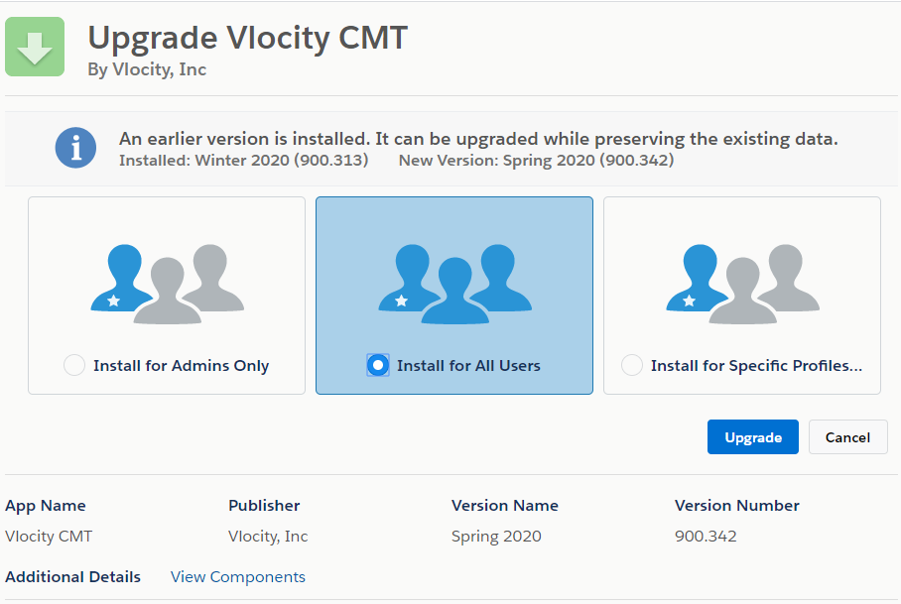

1. If you see the Approve Third Party Access window, select the option to grant access and click **Continue**.

Vlocity packages are large and take longer to install than Salesforce's timeout window allows. (Approximately it will take one hour of time to complete the installation)

1. Click **Done**.

When the Vlocity installation is finished, you will receive an email informing you that the upgrade was successful.

You can check the progress of your deployment:

* 1. Click **Setup**.
  2. Type Environments in the **Quick Find** field.
  3. From the search results, click **Deployment Status**.

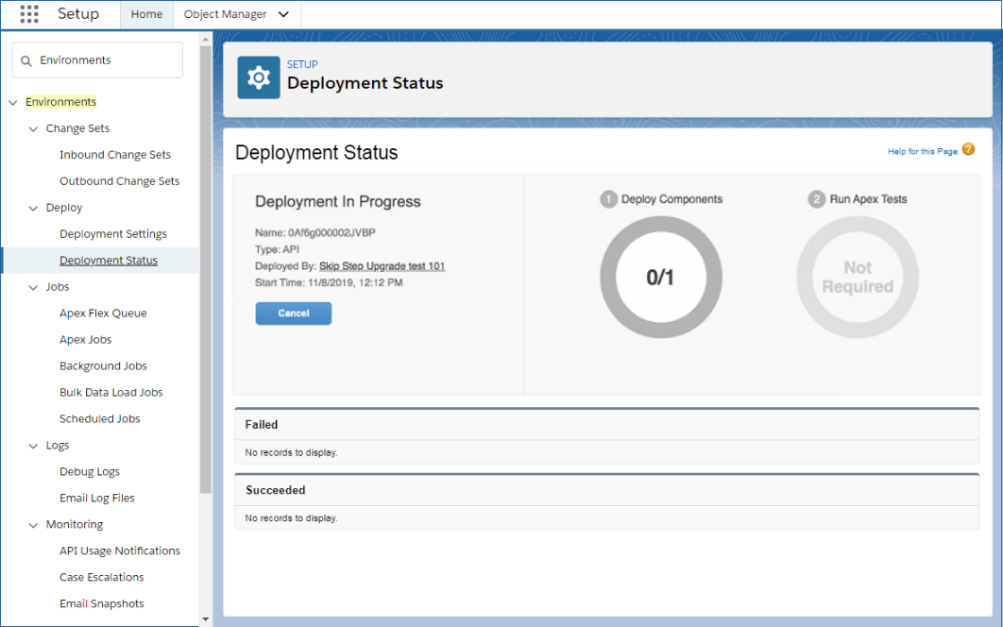

Once the deployment is complete, the status automatically turns green and the version number updates. You do not have to refresh your browser.

# 3. Post Upgrade Steps:

Perform the steps in this section to complete upgrade tasks for Vlocity CME or Vlocity CLM after you have installed the managed package:

1. Configure the default cache partition:
2. From Setup, in the **Quick Find** box, enter *Platform Cache*.
3. Click **Platform Cache**.
4. Beside **CPQPartition**, click **Edit**.
5. In the **Org Cache Allocation** section, set the **Organization** cache to 2.
6. Click **Save**.
7. Repeat steps c to e for VlocityAPIResponse, VlocityMetadata, and OrchestrationItems.
8. Use App Launcher to find Vlocity CMT Administration and perform the following jobs under the respective Admin Console.
9. Run the following Upgrade jobs:
   * 1. [Populate Product Selling Period](https://docs.vlocity.com/en/Upgrade-EPC-Schema.html): Populates Selling Periods datetimes from old Effective dates for each product.
     2. [Populate Requested Start Date](https://docs.vlocity.com/en/Populate-Requested-Start-Date.html) Populates Requested Start datetimes from old Request dates for each order.
     3. [Populate Product Hierarchy Global Key Path](https://docs.vlocity.com/en/Populate-Product-Hierarchy-Global-Key-Path.html): Populates the product hierarchy global key path from the product hierarchy path for Promotion Item and Override Definition objects.
     4. [Update Encrypted Field on Attribute Object](https://docs.vlocity.com/en/Upgrade-Encrypted-Field-on-Attribute-Object.html): Updates the Encrypted field on Attribute records based on attribute assignment data.
     5. [Populate Missing Action Field in XLIs](https://docs.vlocity.com/en/Populate-Missing-Action-Fields-in-XLIS.html): Queries all XLIs (OrderItem, QuoteLineItem, OpportunityLineItem records) that do not have Action_c field populated, uses the ProvisioningStatus__c field value to derive value for the Action__c field and updates Action__c.
     6. [Create Relationship Records](https://docs.vlocity.com/en/Create-Relationship-Records.html): Allows existing customers to update an existing order and it creates the required relationship records for Movement.
     7. [Upgrade EPC Schema](https://docs.vlocity.com/en/Upgrade-EPC-Schema.html): Upgrades the existing product data to populate new fields that support the product Versioning feature for tracking versions of products, picklists, and object types.

Under **Populate New fields**, select **Product2** for the **Object to Upgrade** field. After running this job for **Product2**, run it again for **Object Type** and **Picklist**.

You can use the default setting for this job, which is **200**, or you can enter any value between 1 and 2000.

* + 1. [Multi-Service Upgrade](https://docs.vlocity.com/en/Multi-Service-Upgrade.html): Moves attachment records for group info into Quote Members records. This job also reparents QuoteGroup records from Group Cart to Master Quote.
    2. [EPC Project Item Upgrade](https://docs.vlocity.com/en/EPC-Project-Item-Upgrade-Job.html): Populates the Root Item Id and Global Key fields of Work Set Item records if they are blank.

b. Run the following Maintenance jobs:

* + 1. [Interface Implementation Maintenance (Merge)](https://docs.vlocity.com/en/Interface-Implementation-Maintenance--Merge-.html): Merges existing interfaces and implementations with the default Vlocity interfaces and interface implementations.
    2. [Field Maps Maintenance](https://docs.vlocity.com/en/Field-Maps-Maintenance.html): Creates or restores default Field Mapper settings that the CPQ flow uses to map fields between objects. This job is critical for obtaining the latest field mappings for new fields.

### **Important**

This job deletes any custom maps, so record any custom field mappings you need to restore after this job has run.

* + 1. [Object Map Maintenance](https://docs.vlocity.com/en/Object-Maps-Maintenance.html): Deletes existing object mappings and creates default Object Mapper settings for Opportunity, Quote, Order, Asset, and related objects.
    2. [Product Hierarchy Maintenance](https://docs.vlocity.com/en/Product-Hierarchy-Maintenance.html): Builds the product hierarchies in the Data Store sObject, enabling the Refresh Platform Cache job to use the hierarchy data. Ignore the **Delete Data** checkbox.
    3. [Clear Managed Platform Cache](https://docs.vlocity.com/en/Clear-Managed-Platform-Cache.html): Clears the org cache in the CPQPartition platform cache. The job does not affect other cache partitions.
    4. [Refresh Platform Cache](https://docs.vlocity.com/en/Refresh-Platform-Cache.html): Copies product hierarchy data to the platform cache and rebuilds the product attribute cache.

c. Run the following EPC jobs:

1. [Generate Global Keys](https://docs.vlocity.com/en/Generate-Global-Keys.html): This job creates any missing global keys and assigns them to the correct records.
2. [Install Default Vlocity Objects and Layouts](https://docs.vlocity.com/en/Install-Default-Vlocity-Objects-and-Layouts.html): Installs or restores the default Vlocity objects and layout for object classes. Click Next twice, wait for the import to finish, click Done, and close the DataPacks tab.
3. [Install Default Pricing Plan Data](https://docs.vlocity.com/en/Install-Default-Pricing-Plan-Data.html): Installs the Vlocity default Pricing Plan DataPack.
4. [Create Default Time Policy](https://docs.vlocity.com/en/Create-Default-Time-Policy.html): Creates a default time policy with start policy as purchase date and end policy as end-of-plan duration.

d. Run the following Cacheable API jobs:

1. [Delete Pseudo Records](https://docs.vlocity.com/en/Delete-Pseudo-Records.html): This job deletes the pseudo records created by Digital Commerce APIs. There is no need to edit the fields.

**Note**

* + - 1. There is no need to edit the fields. Click **OK**.

1. [Populate API Cache](https://docs.vlocity.com/en/Populate-API-Cache.html): Processes existing data and populates the API cache.

e. Run diagnostics to check if your configuration settings are correct:

1. From the Vlocity CMT Administration page, click Check Configurations Settings.
2. Click Check.
3. Review the results and make any necessary adjustments. If any items are highlighted in red, follow the on-screen instructions to troubleshoot.

To return to the Vlocity CMT Administration page, click **Back to dashboard**.

1. Install cards and templates:
   1. From the App Launcher, click **Vlocity Cards**, then click the **Additional Actions** arrow in the top-right and install and activate all cards shown.
   2. From the App Launcher, click **Vlocity Templates**, then click the **Additional Actions** arrow in the top-right and install and activate all templates shown.
   3. **Manually activate custom vlocity card & template to display sunrise customized vlocity card**
2. Verify that the StreamingAPI remote site setting has the correct URL.
3. Remove the Billing link from the Account object. To perform this step, use Salesforce Classic.
   1. From Setup, in the **Quick Find** box, enter *Accounts*.
   2. In the left panel, under **Build**, click the arrow beside **Customize** to expand the list.
   3. Click the arrow beside **Account** to expand the list.
   4. Click **Buttons, Links, and Actions**.
   5. Find and delete the **Billing** row.
4. Deactivate workflow rules:
   1. From Setup, in the **Quick Find** box, enter *Workflow Rules*.
   2. Click **Workflow Rules**.
   3. Click **Continue**.
   4. Deactivate Vlocity Workflow rules that start with Asset or ReferenceId:
      * AssetPricingAdjustmentRefIdForOLIPA
      * AssetPricingAdjustmentRefIdForQLIPA
      * AssetRefIdForOLI
      * AssetRefIdForQLI
      * ReferenceIdForOrderAppliedPromotionItem
      * ReferenceIdForOrderPriceAdjUpdate
      * ReferenceIdForOrderPromotionUpdate
      * ReferenceIdForQuoteAppliedPromotionItem
      * ReferenceIdForQuotePricingAdjUpdate
      * ReferenceIdForQuotePromotionUpdate
5. Ensure a default language is set:
   1. In **Quick Find**, search for *Picklist Value Sets*.
   2. Click **Picklist Value Sets**.
   3. Click **Vlocity Locale Code**.
   4. Ensure a base language is selected. If not, select your base language and set it to **Default**. If the value (base language) is inactive, then activate it.
   5. 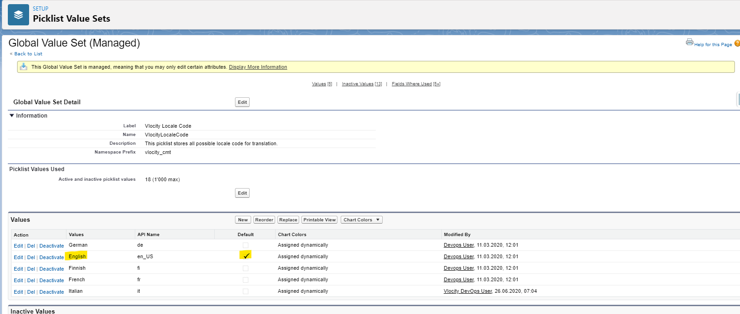Here the default language will be English.
   6. Activate only the languages to which the data will be translated.
6. To upgrade the Vlocity Product Designer, see [Upgrade Vlocity Product Designer](https://docs.vlocity.com/en/Upgrade-VPD-Spring--21.html).
7. If you use Contract Life Cycle Management (CLM), see [Post-Upgrade Steps for Vlocity Contract Lifecycle Management for Vlocity Communications, Media, and Energy Summer '21](https://docs.vlocity.com/en/Post-Upgrade-Steps-for-CME-CLM-Summer--21.html).
8. If you use Vlocity Order Management (OM), see [Post-Upgrade Steps for Order Management Summer '21](https://docs.vlocity.com/en/Post-Upgrade-Steps-for-Industries-Order-Management-Summer--21.html).

**Note: Please don’t perform the below mentioned steps.**

* + 1. Order Management Plus: Set DataRaptors to Sync from Salesforce to OM Plus
    2. Order Management Standard (optional): Set up Platform Events
    3. If You Are Upgrading from a Version Earlier Than Fall '20: Upgrade the Priority Queue Picklist
    4. Add the Sales Bundle Scope to the Appropriate Picklists
    5. OM Plus only: Set appropriate dataraptor bundles and dataraptor map items to be synced
    6. OM Plus only: As a test, submit an order from Salesforce to OM Plus

1. Due to a compiler change, redeploy any active Lightning Web Component OmniScripts you have created. Go to [Deploy an LWC OmniScript](https://docs.vlocity.com/en/Deploying-an-LWC-OmniScript.html) and follow the steps to deploy.

Note: Please use the below file to deploy active LWC which is mentioned in step 11.

[**DataPack Link**](https://sunrisecomm.sharepoint.com/:u:/r/sites/SunrisegoesSalesforceVlocity/Shared%20Documents/General/Vlocity%20Upgrade/datapacks%20(1).zip?csf=1&web=1&e=F56u0b)



1. Steps to remove “XOMExecuteCustomOmniscript” Vlocity action from Vlocity toolbar.
   1. Login to Salesforce and search Vlocity action in the App Launcher
   2. Change the list view from Recently Viewed to All
   3. 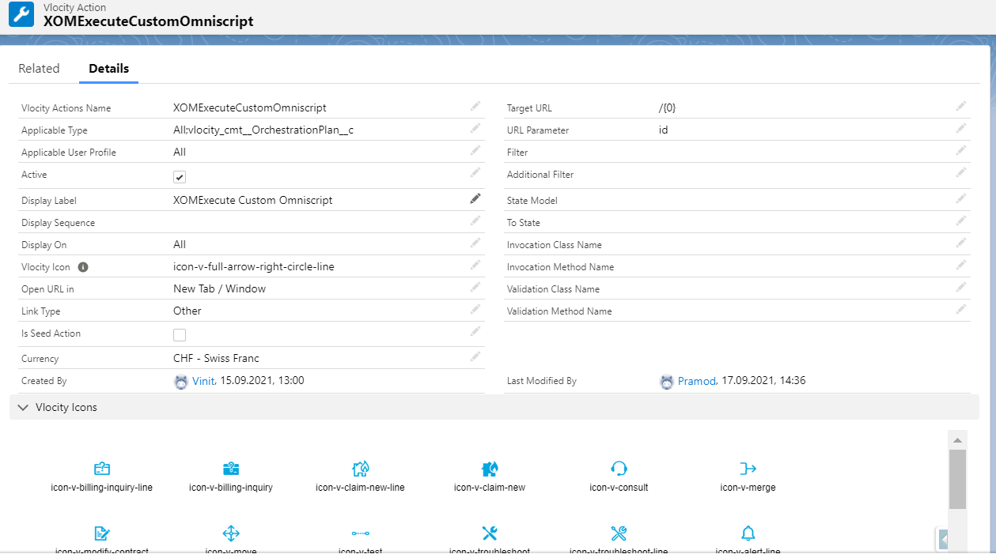Search for “XOMExecuteCustomOmniscript” and open it.
   4. 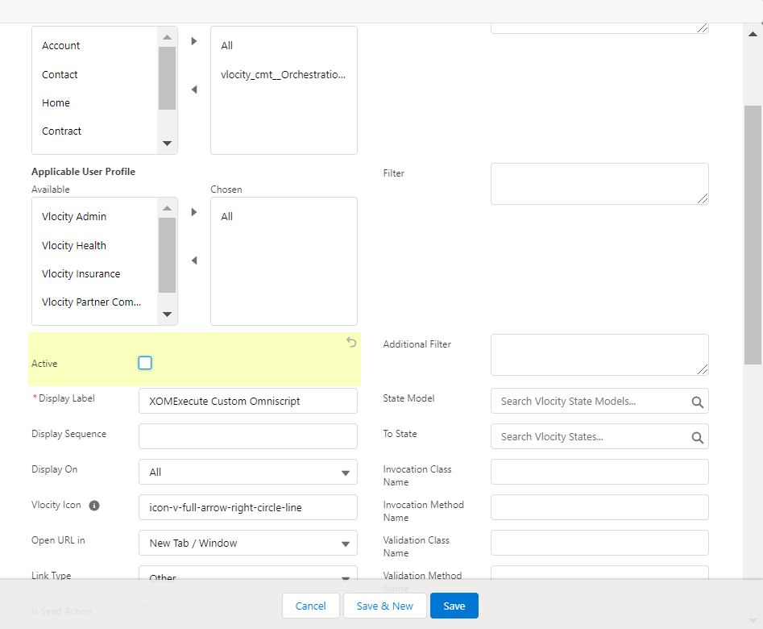Click on edit and deselect the active checkbox and click Save.
2. Steps to verify, if after clicking on view record button on the cart page, it is redirecting to classic record page instead of Lightning
   1. Open the Vlocity actions, search for “View Record” action.
   2. In the target url field, paste the following code: /{0}
   3. Make sure the Open url in is updated as “Current Window”
3. In the App Launcher, Party relationship is not visible
   1. Go to System Admin profile and click on “Object Settings”.
   2. Search for “**Party Relationships**” and click on edit.
   3. In the Tab Settings, select “Default On” and click on Save.
   4. To test the relationship, create a test Party Relationship between two accounts.
   5. Click on any of the account to see whether the relationship graph is visible or not.
   6. If not then, search for **Relationship Graph traversal** in the App launcher.
   7. Make sure the correct “Relationship Type Value” is updated in the field with respect to target label (**Member Relationship, Delegate Relationship, Partner Relationship**)
   8. 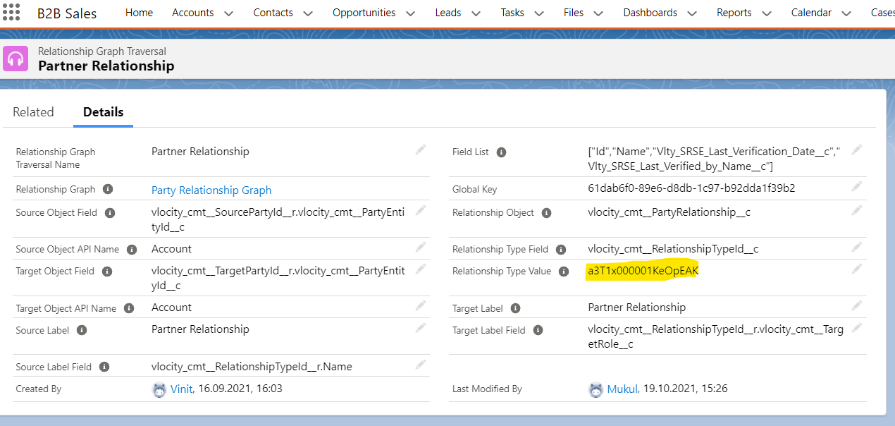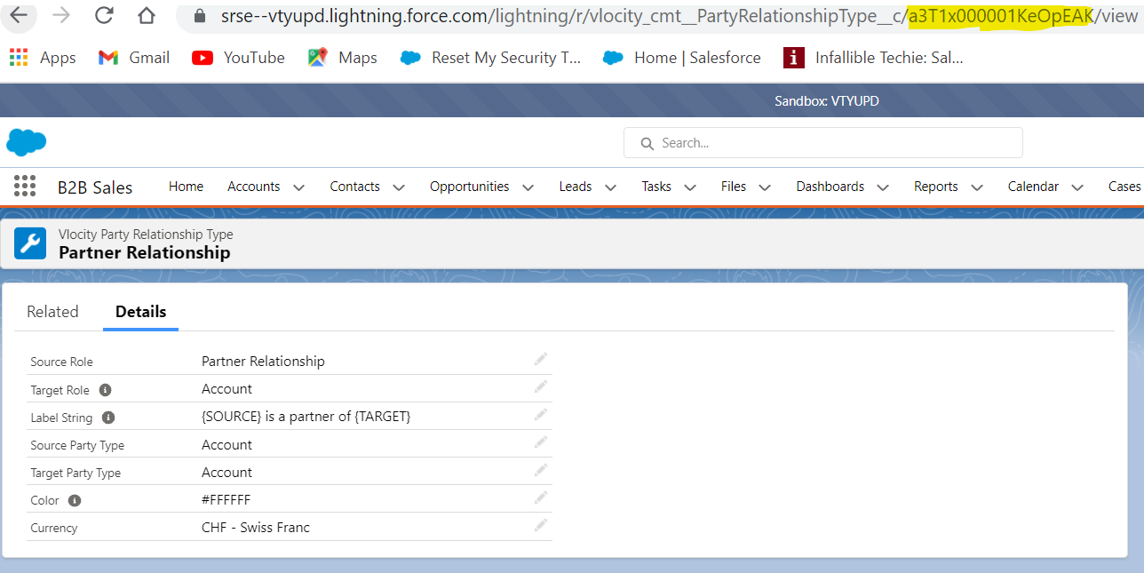For example, if in the Target label, party relationship is updated, then the correct Party Relationship Type (Partner Relationship) value which if of 18 digit should be updated in the Relationship Type Value field.
4. Refresh Platform Cache
5. Login to Salesforce
6. Click on settings gear icon on top right corner
7. In Quick Find, search for ‘Platform Cache’
8. Open ‘Platform Cache’
9. Open ‘CPQPartition’
10. Click on Clear Cache button
11. Popup will be shown, click on OK
12. Run EPCProductAttribJSONBatchJob in Developer Console
13. Click on “Settings” gear icon and Open “Developer Console”
14. From “Debug” menu, choose “Open Execute Anonymous Window”
15. Paste below code

*List<Id> productIds = new List<Id>();*

*for (Product2 prod : [ Select Id from Product2 where vlocity_cmt__ObjectTypeId__c != null or vlocity_cmt__ProductSpecId__c != null ]){productIds.add(prod.Id);}Database.executeBatch(new vlocity_cmt.EPCProductAttribJSONBatchJob(productIds), 1);*

1. Click on “Execute” and Close Developer Console
2. To verify the batch job completion, Click on “Settings” gear icon and Open “Setup”
3. In Quick find, search for “Apex Jobs”
4. Check whether Batch Apex job is completed



1. Run Product Maintenance Job
2. Navigate to "App Launcher" and search for "Vlocity CMT Administration".
3. Select the "Maintainance Jobs".
4. Start "Product Hiearachy Maintainance" and check whether it is completed successfully.
5. Start "Clear managed Platform Cache" and check whether it is completed successfully.
6. Start "Refresh Platform cache" and check whether it is completed successfully.